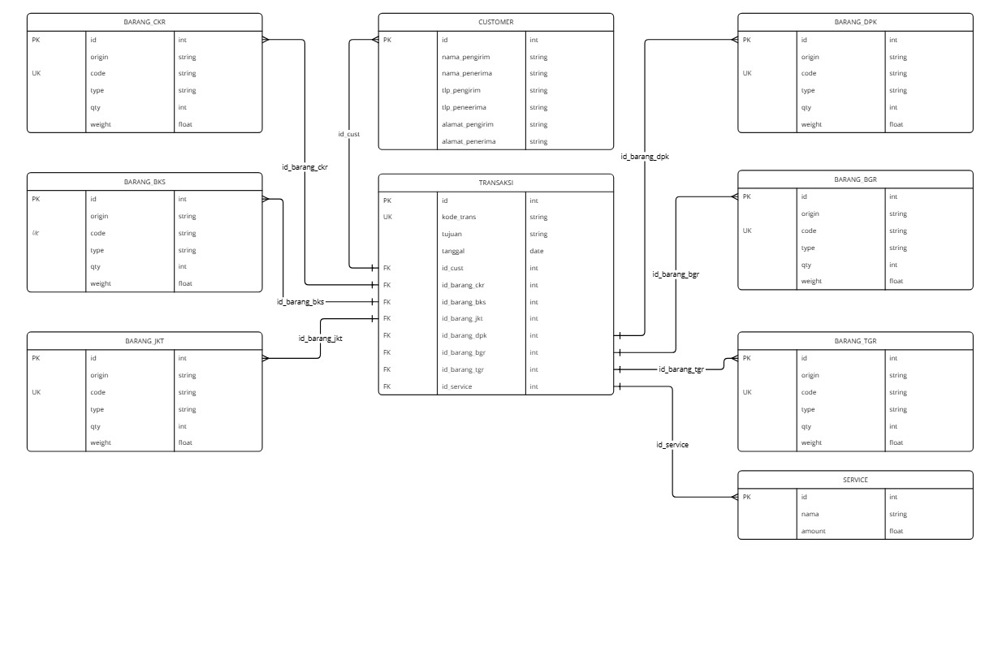
Struktur Tabel Cost to Cost

- FLOWCHART ADMIN
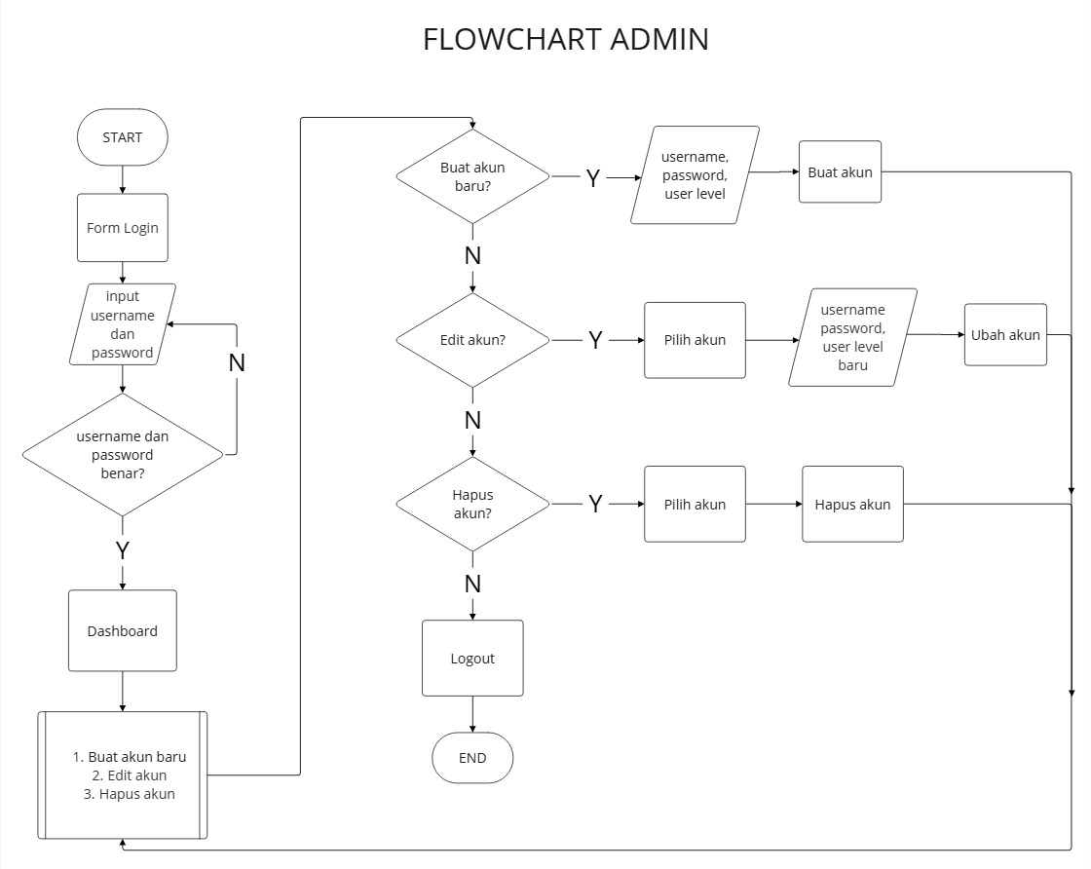

2. FLOWCHART FINANCE
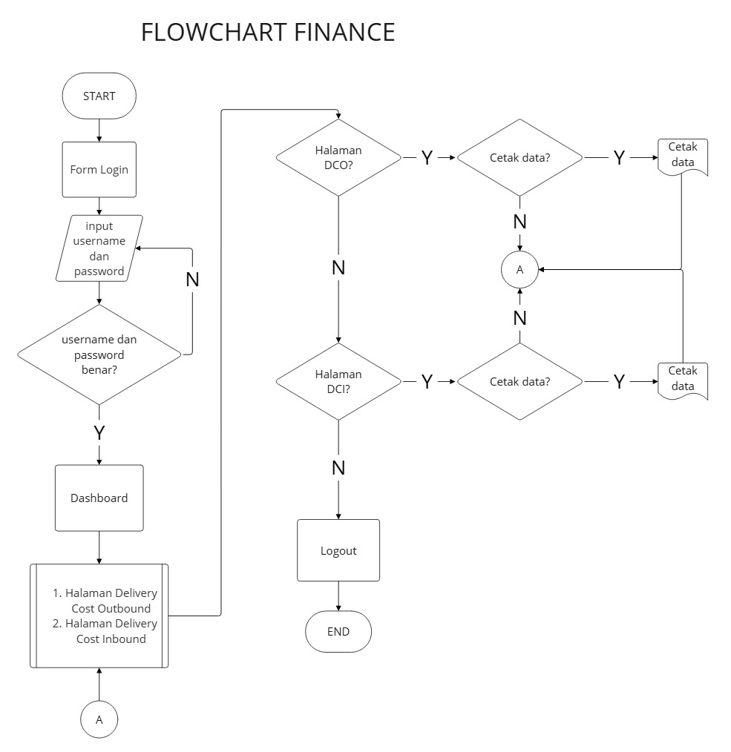

3. FLOWCAHRT SALES COUNTER
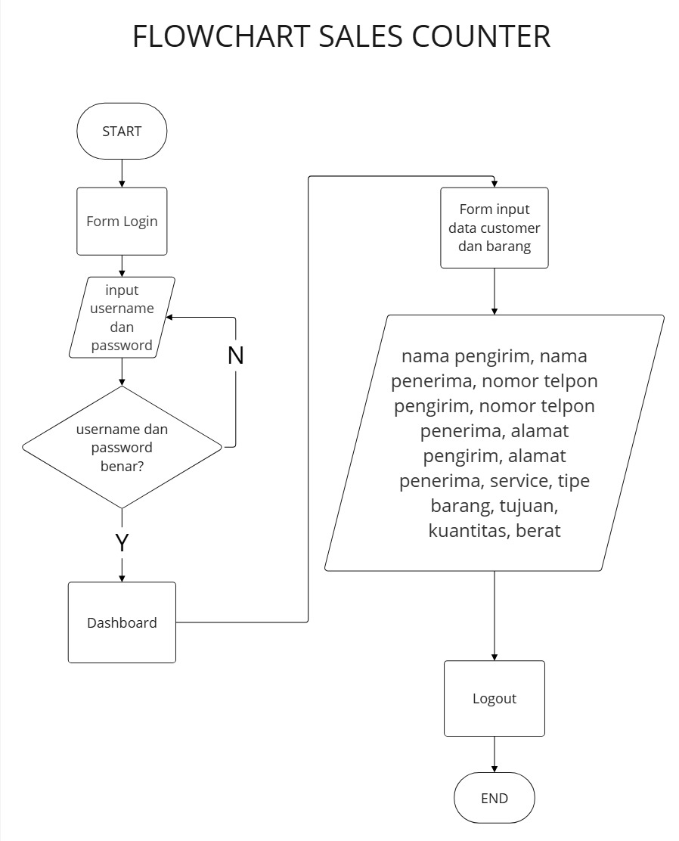
4. ENTITY RELATIONSHIP DIAGRAM (ERD)
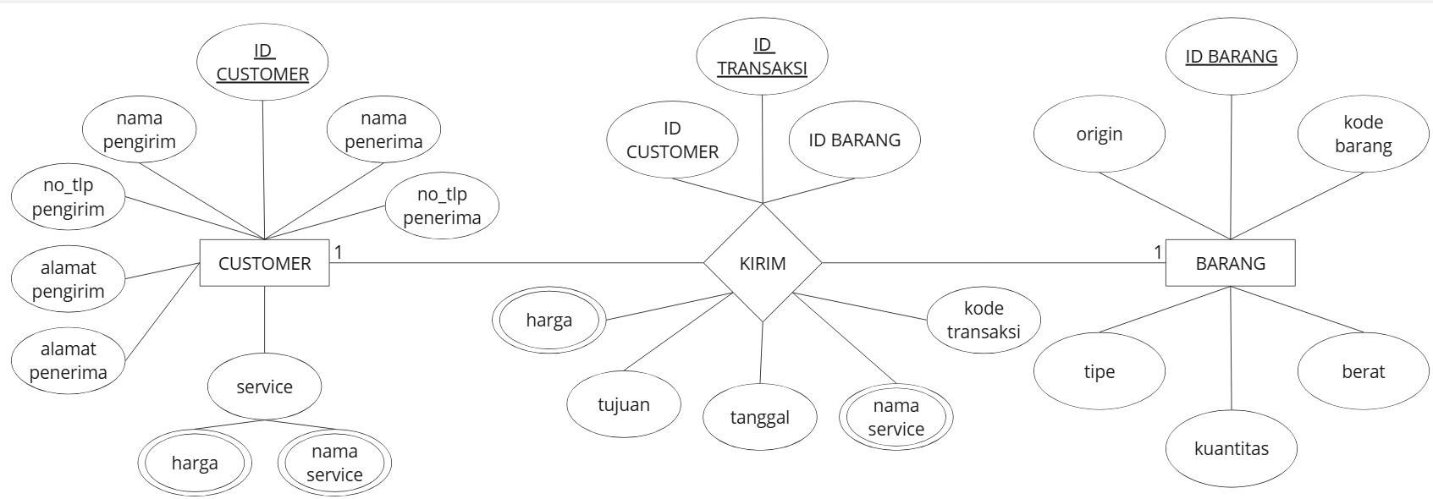

5. DATA FLOW DIAGRAM (DFD)
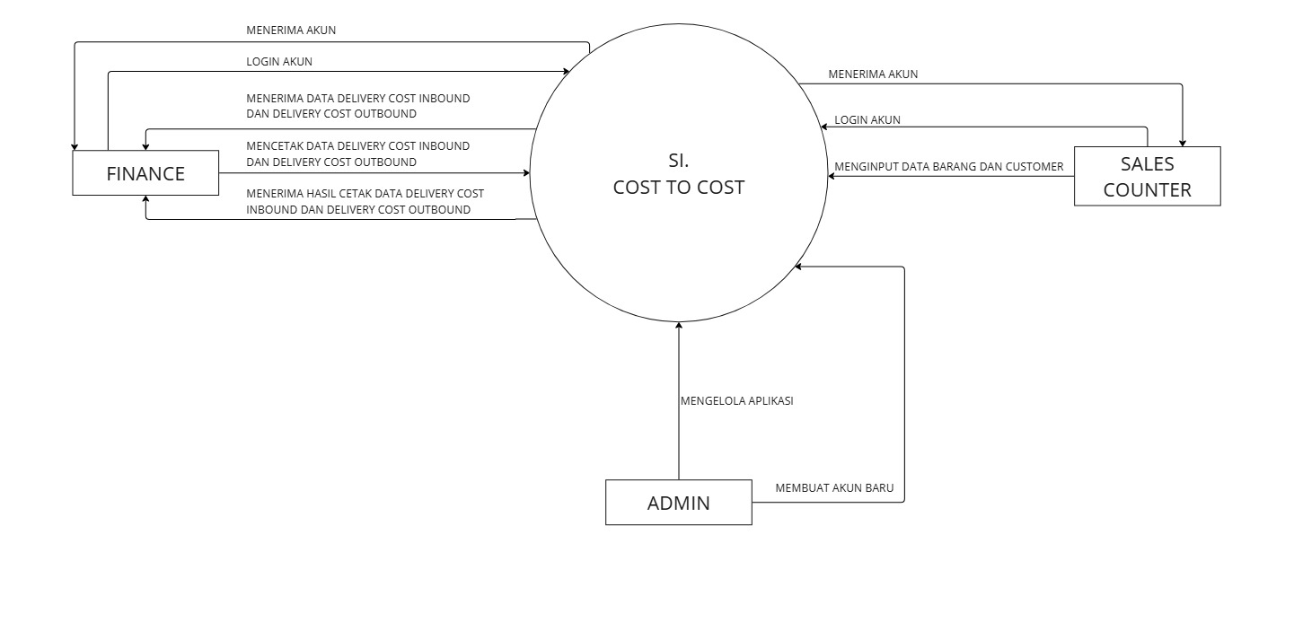
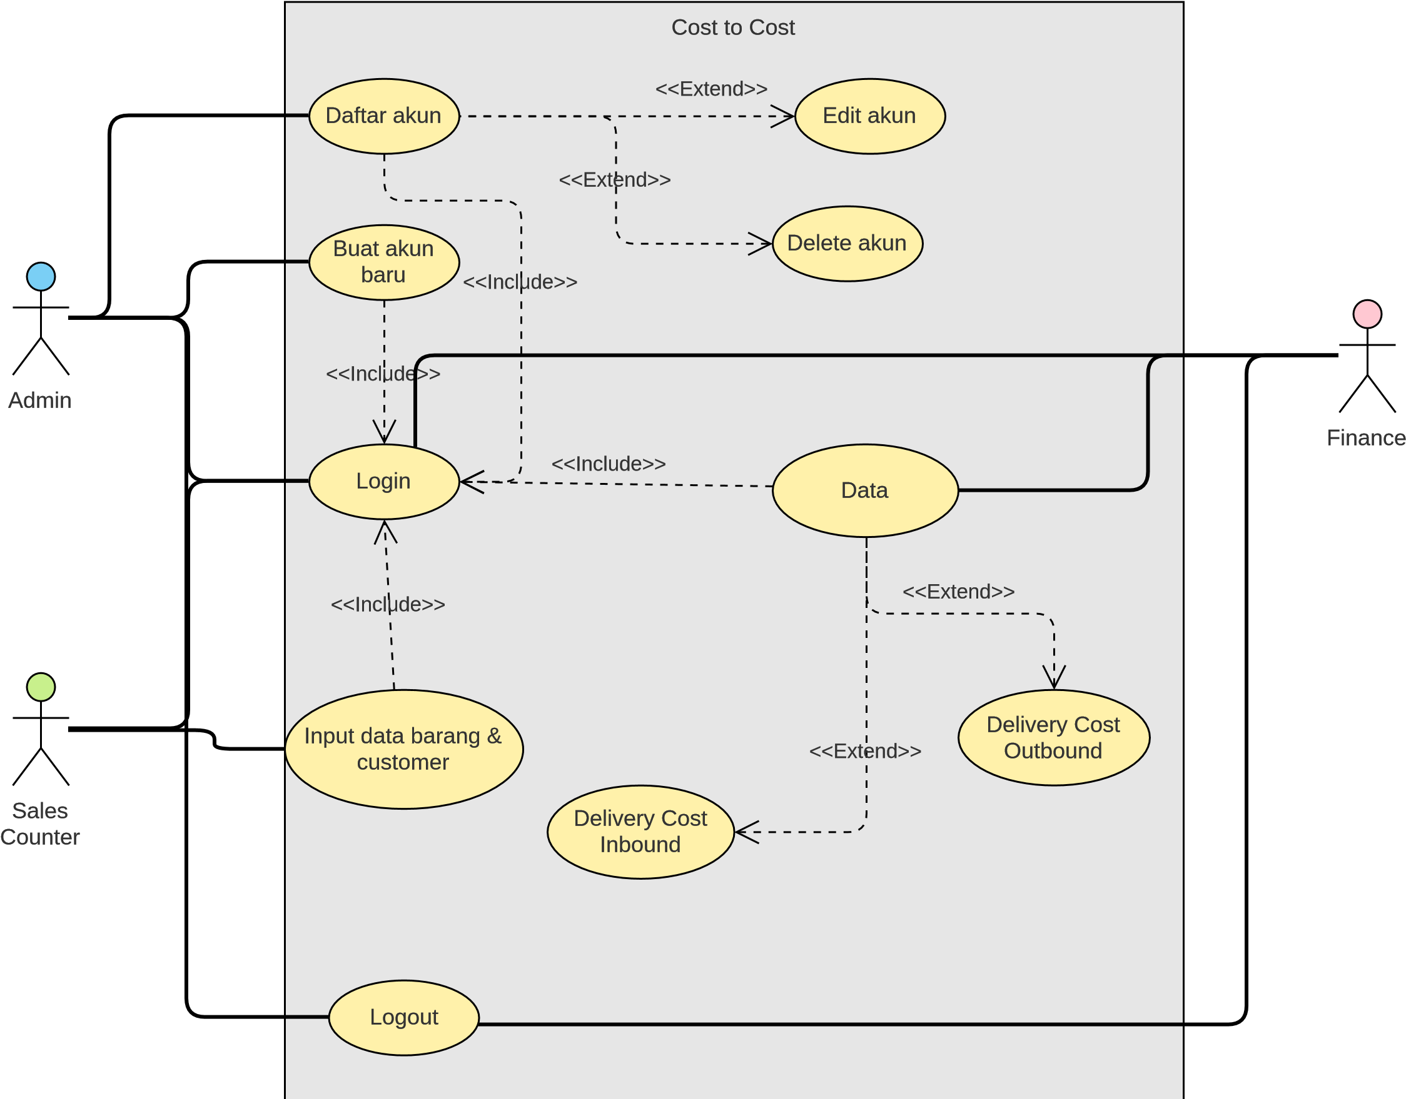
6. USE CASE DIAGRAM

7. ACTIVITY DIAGRAM
Login Admin
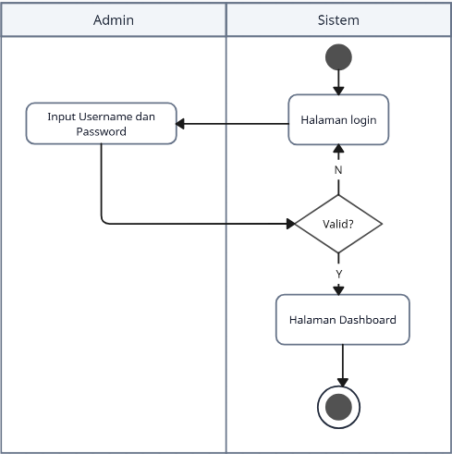

Proses Admin
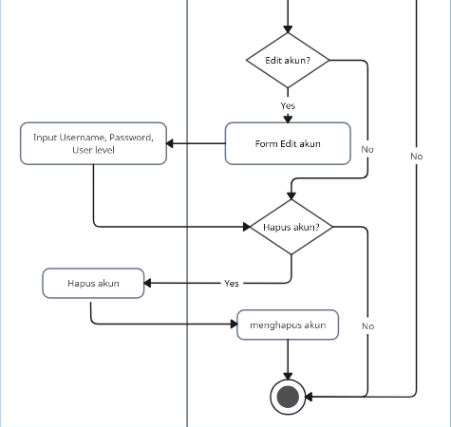
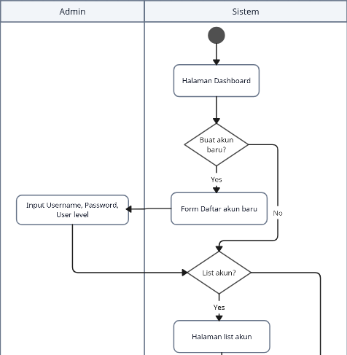

Logout Admin
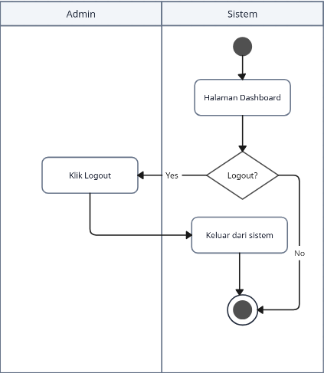

Login Finance
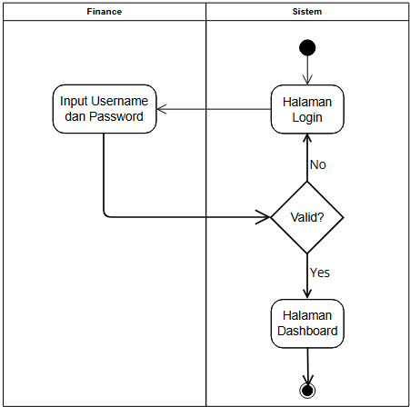

Proses Delivery Cost Inbound
Finance
Klik cetak data
Pilih Data DCI
Sistem
Halaman
Dashboard
Data delivery Cost
Inbound?
Cetak Data?
Yes
Yes
Halaman
Delivery Cost
Inbound
Mencetak Data
No

Proses Delivery Cost Outbound
Finance
Klik cetak data
Pilih Data DCO
Sistem
Halaman
Dashboard
Data delivery Cost
Outbound?
Cetak Data?
Yes
Yes
Halaman
Delivery Cost
Outbound
Mencetak Data
No

Logout Finance
Finance
Klik Logout
Sistem
Halaman
Dashboard
Logout?
Yes
Keluar dari
sistem
No

Login Sales Counter
Sales Counter
Input Username
dan Password
Sistem
Halaman
Login
Valid?
No
Halaman
Dashboard
Yes

Input Data Sales Counter
Sales Counter
Input Data
Sistem
Halaman
Dashboard
Input Data?
Yes
Submit Data
No

Logout Sales Counter
Sales Counter
Klik Logout
Sistem
Halaman
Dashboard
Logout?
Yes
Keluar dari
sistem
No

